2019

Quincy country club
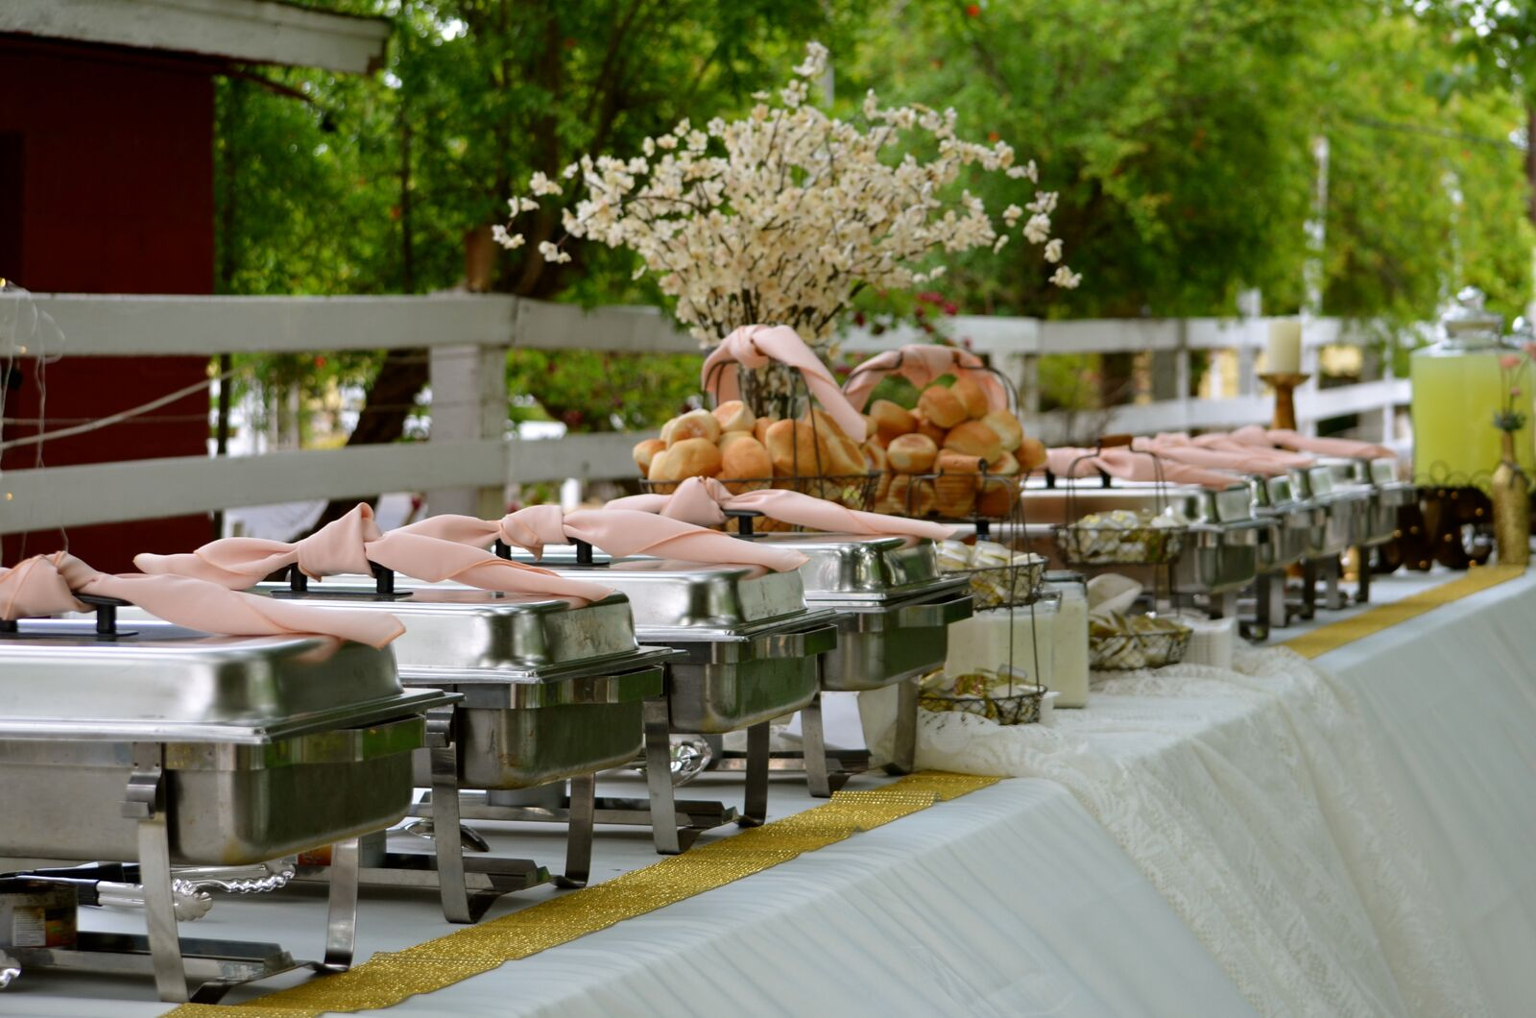

Catering services

planning guide

Fine dining & Cuisine at its best…just for you.

Event Date: _____________________________________________________________________, 20_________

Time of Event: - Number of Guests:__________Location:_______________________

Member Name: ______________________________________________ Member #: ____________________

BANQUET POLICIES
Please contact our Club Manager for any assistance you may need in menu selections. Your menu selections and total arrangements must be confirmed at least two (2) weeks prior to your scheduled function.

PAYMENTS/Rental
All nonmember functions must be sponsored by a member within the Club. In the event that the nonmember fails to fulfill his/her obligations in payment for all services provided by the Club, the sponsoring member would be obligated to pay for all damages, etc., due to the Club.

Non Member Sponsored events will be charged a Room Rental fee of $5.00 per person.
Inside Wedding Ceremonies will be charged a $200.00 room Turnover charge
Outside Wedding Ceremonies will be charged a $200.00 set up/tear down fee.
All outside reception tables, chairs, glassware and tableware will be rented and charged.

SPECIAL SERVICES
All decorations must conform to the Club rules. Our Private Events Department will be happy to coordinate services including florists, music, specialty items, audio / visual, entertainment, specialty cakes and much more.

LOST AND FOUND
The Club will not assume responsibility for damages or loss of items left in the Club prior to, during, or after a function.

SMOKING
Smoking is permitted outside only. Please tell the Private Events Director if you require an area for smoking.

TAX AND SERVICE CHARGE
All food and beverage orders are charged a 20% service charge and 8.0% sales tax.

DRESS CODE
Resort casual attire is required at the Club. Resort casual attire is defined as collared shirt and dress shorts or slacks for gentlemen. Full cover-ups over swim attire are required throughout the Clubhouse. No denim jeans or shorts are allowed.

MENU SELECTIONS
A single entrée selection is strongly recommended for all functions. Should a second choice be necessary (no more than two entrees), it can be provided for parties of 100 people or less provided the following conditions are met:
The exact number of entrees must be provided to the Club at least 72 hours in advance of the function.
Identification in the form of color-coded place cards or other method must be provided by the host so that the wait staff can serve you properly and without delay.
When two choices are offered, the exact number of each entrée must be prepared in advance. Therefore, the host will be charged for that count plus any last minute changes.

BEVERAGES
Alcoholic beverages cannot be brought into the Club from outside sources. Alcoholic beverages are regulated by the State of Illinois. The Club is responsible for the administration of these regulations. All bar charges are priced on a per-drink basis. The Club reserves the right to discontinue service at its discretion.

ESTIMATED CHARGES
A guaranteed guest count is required by 10:00 a.m. three (3) business days prior to the event. The guaranteed number will be the minimum amount charged. The Private Events staff will be able to provide estimated charges at the time of the event booking. Each event is charged by the actual totals, not the estimate. All buffet prices are based on a 1 & ½ hour buffet. The Club will prepare 5% more food than the guaranteed estimate. In the event that the group’s attendance is more than 5% over the guaranteed number, the client grants Quincy Country Club the right to substitute and adjust prices as necessary to service its guests.

Quincy Country Club
Quincy Country Club is happy to be able to serve you and your guests for your reception and offer the following services to add or enhance that experience.
Usage and Off Site Catering Fees
Italian Lights……………$175.00
Projector………………..$45.00
Screen……...……………$50.00
Delivery/Pick-Up and Set up…………………..$100.00
Bartenders…………………..$30.00 per hour
Wait-Staff……………………..$20.00 per hour
Bus Staff…………………………. $15.00 per hour
Meat Carver…………………. $20.00 per hour
(Gratuities can be given to staff if desired above and beyond the hourly rate)
Beverage Services
Quincy Country Club cannot supply alcoholic beverages for off-site catering events. Should you need assistance in planning for beverage services, you may contact Steve Forrest at 223-3452 for suggestions. Quincy Country Club can provide non-alcoholic beverages, garnishes and mixers at your request. All mixers will be charged $1.00 per drink, soda at $1.25 per can and Full Garnish service for beverages will be charged $45.00. Bar glasses may also be provided for a rental charge of $50.00 for every 50 guests.
Food Services
Please see our 2014 Banquet planning guides that best fit your engagement for options and prices. All catering events are set up buffet style. Plates can be providing for a rental of .50 per person for dinner plates and .25 per person for salad and dessert plates.
All charges will be billed on member account.

Linen Services
We will be happy to provide you with quality pressed linen for your seating and buffet tables
Round Table cloths………$6.00 per cloth
8 Foot Table cloths………. $4.00 per cloth
Skirting…………..$25.00 per skirt
Napkins………………..$.25 per napkin

