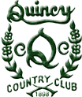
Club “Experience”
quincycountryclub.org
“Honoring Tradition, Embracing Change.”
125 years -1898-2022

Thank you for reaching out to us on our web site!

Due to fluctuating prices
Please call Amy or Matthew at
217 223-3452 to receive the most updated reception Listing.

Thank you for allowing us to
serve you here at QCC!

Matthew Mulherin
Manager
qccgm@adams.net

