Quincy Country Club
Summer Tennis 2023
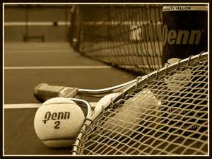
Mike Terry, USPTA
Director of Tennis/Head Professional
217-430-8172 cell or terry@jwcc.edu

Tennis Staff
Todd Willing
USPTA, Asst. Professional
Monica Hinkamper
USPTA/USPTR, Asst. Professional
Rain Plan
In case of rain, women’s and junior classes will be held at the
Quincy Racquet Club
3336 State Street
217-224-6161
Junior Tennis 2023
SIGN UP: May 20th 10:00 am – 12:00 pm
Monday Classes held June 5th - July 24th
Junior tournament and skills contest – July 24th
At Quincy Country Club
NEW SCHEDULE for 2023
All ages from 3 years of age and UP
Mondays at the Courts
1st Class at 9:00am
2nd Class at 10:00am
You can choose one or the other that works best with your schedules or feel free to do BOTH!
Women’s/ Men’s Cardio Tennis
Thursday classes held June 8th - July 27th
8:00-9:00am
Women’s Member/Guest
Thursday July 27th
Tennis 9:00 am-11:00am
With lunch served at 11:30am
Tournaments
QCC Adult & Junior Championships
Formats to be announced.
To participate, Contact Mike Terry

Triples Tennis

Monday May 22nd
6:00 pm – 7:30 pm
Limited to the first 18 players
The QCC tennis staff is looking forward to another fun-filled summer of tennis activities:
Junior Group Lessons
Cardio Tennis
Private Lessons:
If you need a little special attention or would like to work on your game before entering group lessons or cardio tennis, Mike Terry offers private lessons by appointment.
Rates:
1hr Private- $50.00
1/2hr. Private-$30.00
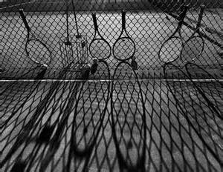
1hr Group-$100.00

